REVIEW SHEET
QUARTERLY EXAM

Culture and Communication
What is the definition of “communication?”
What are the five parts of the communication model?
What is the definition of “culture?”
What are two classifications of communication – both based on size of audience.
What is a movie?
What is “frame rate?”
Name two early pioneers in film.
What are “conventions?”

Scriptwriting
When do you use ALL CAPS in a script?
In a script, you center justify WHICH CONTENT?
Where do you go to find school announcements for your script?

CODECS
What is a codec?
Name one we use while editing in Premiere?
How do you check your sequence to see what CODEC you’re in?

Working in Premiere Pro
How do you import video?
How do you import audio?
How do you adjust volume levels in your edit?
Why is it important to ingest your media, rather than working from your SD card?
Which workspace do you click on to create a title?
How can you tell when audio is too loud?
How do you mark an in point?
How do you mark an out point?
How can you export to YouTube directly from Premiere?

Please be able to identify all the letters on the graphic on the next page.
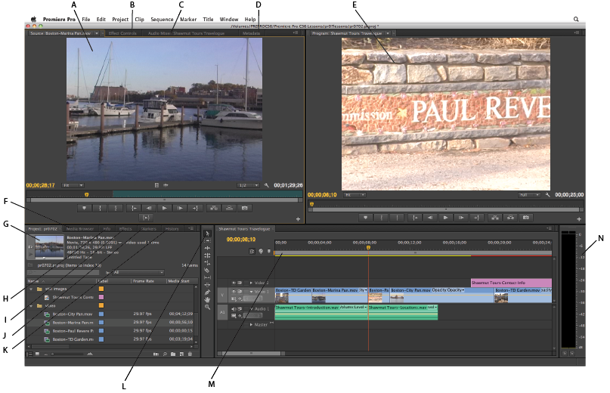
YOUR EXAM WILL NOT BE OPEN BOOK, OR OPEN NOTES.

